[**Module 04 Lesson – Determining Audience Needs**](https://learning.rasmussen.edu/webapps/blackboard/content/listContent.jsp?course_id=_67422_1&content_id=_6076797_1&mode=reset)

**Reading** -

* *Data Visualization: A Successful Design Process*
  + Chapter 3. Demonstrating Editorial Focus and Learning About Your Data
    - Permalink: <http://go.oreilly.com/rasmussen-college/library/view/data-visualization-a/9781849693462/ch03.html>
* *Storytelling with Data: A Data Visualization Guide for Business Professionals*
  + Chapter 4 Focus your audience’s attention
    - Permalink: <http://go.oreilly.com/rasmussen-college/library/view/storytelling-with-data/9781119002253/c04.xhtml>
  + Chapter 5 Think like a designer
    - Permalink: <http://go.oreilly.com/rasmussen-college/library/view/storytelling-with-data/9781119002253/c05.xhtml>

Determining Audience Needs

All content that is intended to be consumed by an audience should be developed with the audience’s needs in mind. Too often, content is produced for the sake of completing a task, or from the author’s point of view that little consideration is given to how that content will be received. And while it may seem simple to create a document, or post, or marketing material for the audience, it is not. Audiences are very diverse. They come from different cultural backgrounds. They have different perceptions about the world, about data, and about products and services. Audiences are full of opinions both right and wrong, and everyone is entitled to their own opinion. An audience does not have to justify why they like or dislike something, they just do. So while all audience needs cannot be met, attention can be given to the general needs of an audience, and it begins with having a plan for how to communicate to an audience.

First, intent must be established for any content which is produced for an audience.

* *What is the goal?*
* *What is the purpose for the communication?*
* *Why is this information being communicated to the audience?*
* *What should the audience do with the information after they receive it?*

These questions will begin to frame the intent for the communication and offer some guard rails for keeping the communication in-line with audience needs.

Once the intent for communication has been established, consideration must be given to the target audience. The makeup and skillset of an audience is sometimes known. For example, let’s say that a corporate trainer is delivering a presentation to newly hired customer service representatives. The trainer will understand that the audience may come from different backgrounds and have many questions. Not only will the audience have a need to learn the material, but may also be feeling some anxiety about starting a new job. The trainer should recognize the situation and consider this in the tone of the communication.

On the other hand, a trainer could be delivering an annual training on conducting employee reviews to a group of managers where only one or two of the managers are new. The training may be aware that the audience is mostly experienced in the process and that the meeting is mandatory review of company guidelines. Some experience managers may know the process well, but be required to sit through the meeting anyway. Once approach for this trainer may be to cover the essentials of the training material while highlighting any procedural changes which are new to the process.

The needs of the target audience is in part focused on general communication. Sometimes that involves the communication of data. When done visually, other elements of visual communication must be introduced. For instance, how will the audience receive the communication? When receiving data visually, it is most likely to occur on an electronic device. Computers, laptops, tablets, and mobile phones are the most common form factors in which data visualization occurs, setting aside the various software applications which are used. The originator cannot consider every scenario, but certainly a very detailed spreadsheet with hundreds of rows and columns would not be the best choice to view on a cell phone.

**Clutter, Whitespace, and Color**

When communicating data visually, one approach is to simplify the message, but retain the meaning. Remove any unnecessary content that is not required or does not support the intent. Such data is considered to be **“clutter”** and only clouds the data visualization. In addition, humans can only perceive a limited amount of data cognitively. So the more straightforward the communication, the better is it for the audience. Sometimes though, visual communication can have the opposite effect of “clutter” and include too much **“whitespace.”** This gives a sense of emptiness and a perception that content is missing or inadequate. There should be a balance in the use of content and the display area.

Language skills and learning also play a role in how humans perceive information. In the United States, people have been taught since grade school to read from left to right, and top to bottom. The use of color has been engrained, such that color conveys a particular meaning, or mood. The use of a bright red color for text may indicate errors, mark-up, or draft. Whereas, black text is generally accepted as valid, and blue text for hyperlinks. There is validity on the use of color in data visualization, but it should be used in a manner which conforms to the visual learning of the audience.

In order to demonstrate the elimination of clutter and effective use of color, take a look at the series of graphs below It starts with an original graph, then removes various elements to clean up the clutter and align the color presentation. Notice how as the chart border, gridlines, and markers are removed, and the axis labels are cleaned up, the chart becomes more readable.

*Figure 4-1 Original Graph*

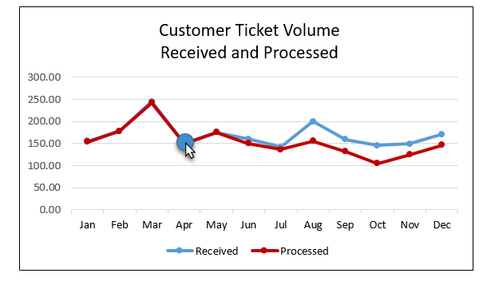

*Figure 4-2 The Chart Border Has Been Removed*

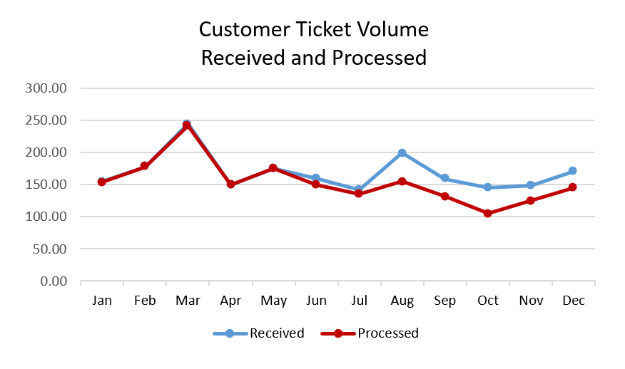

*Figure 4 -3 The Gridlines Have Been Removed*

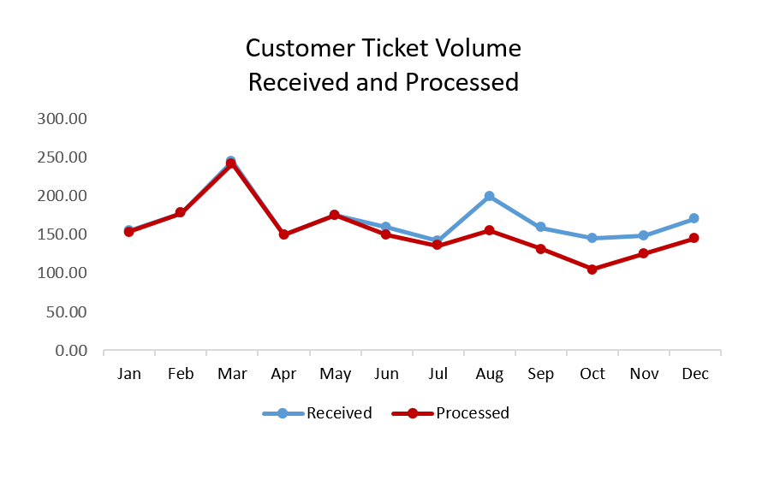

*Figure 42-4 The Data Markers Have Been Removed from The Chart Lines*

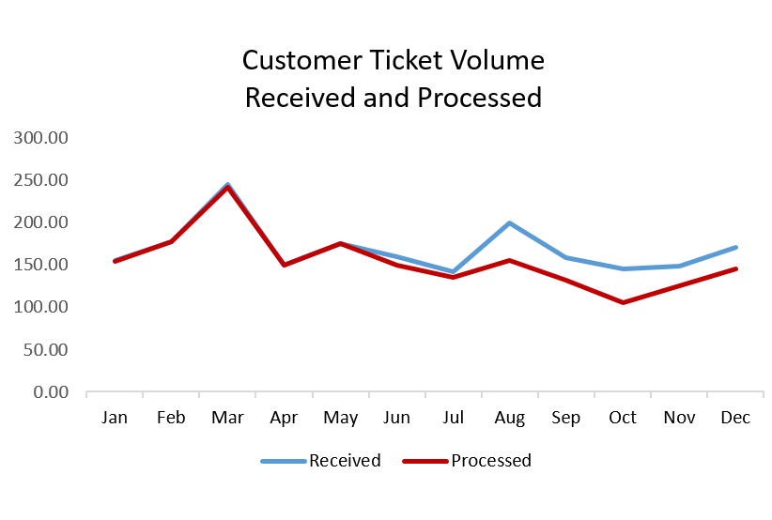

*Figure 4-5 The Decimal Places on The Y-axis Have Been Simplified*

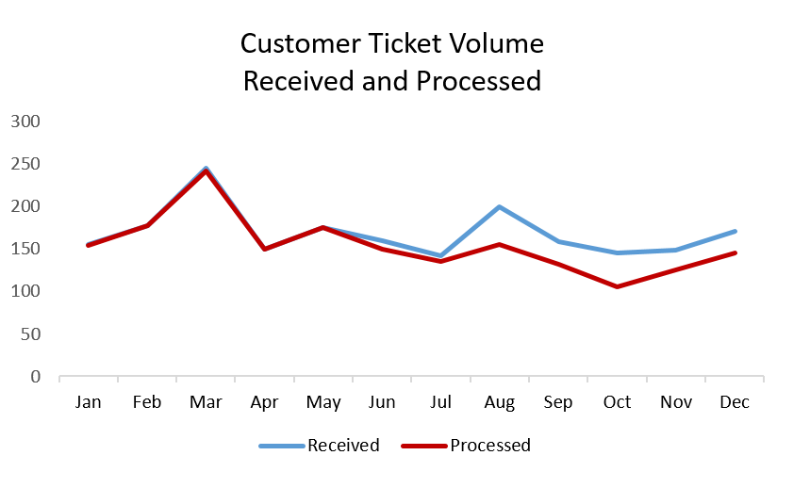

*Figure 4-6 The Chart Title Has Been Removed*

*Module 04 Lab Lecture*

*The purpose of this lab lecture is to provide you with background and guidance to complete the Module 04 Lab.*

*One of the skills that is critical for data analysts to have is the ability to tell a story with data. Analyzing data is not sufficient by itself. Generating insight is key, but insight alone does not deliver the message to business stakeholders. Sometimes the analysis of data and the derived insights involve complicated subject matter. The data analyst needs to be able to explain the data, conclusions, and recommended actions in a way that appeals to a broad audience. Creating a story that business stakeholders will be able to understand gets the message across to those who need the information to make decisions.*

*The purpose of storytelling with data is to effectively communicate your message and get your audience to react in a manner that you desire. Stories should be impactful and compelling. They should cause the audience to consider the points that are made, react by taking action, or understand the implications of not taking any action. To create an effective story, consider the following:*

* *Provide a contextual background about the situation*
* *Give examples that illustrate the problem or business issue*
* *Include data points that demonstrate the issue*
* *Explain the risks or impact of not addressing the issue*
* *Offer potential options to address the issue*
* *Illustrate the benefits of the available options*
* *Help the audience understand why they are in the best position to make a decision*

*By following this guidance, your stories will be formatted to gain support from the audience. In order to effectively communicate the story visually, it helps to employ a data visualization tool. In this Lab, you will use Tableau to create story points. Within Tableau, story points provide a caption that helps explain the data. These captions are brief and are shown at the top of the selected graph or map.*

*In order to access and create story points, you will go to the Tableau Learning Center. You will access the Dashboard and Stories video series and look for the video called “Story Points.” That section will look like the image below:*

*Figure L4-1 Tableau Video Story Points*

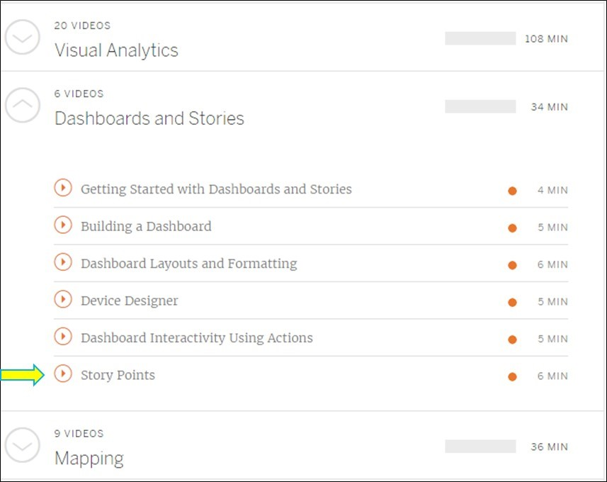

*Once you view the video, you can complete the Module 04 Lab.*

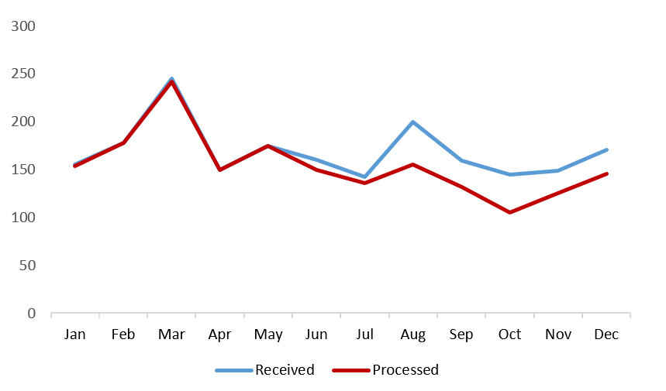

*Figure 4-7 The X-axis Labels Have Been Removed and The Lines Labeled Directly*

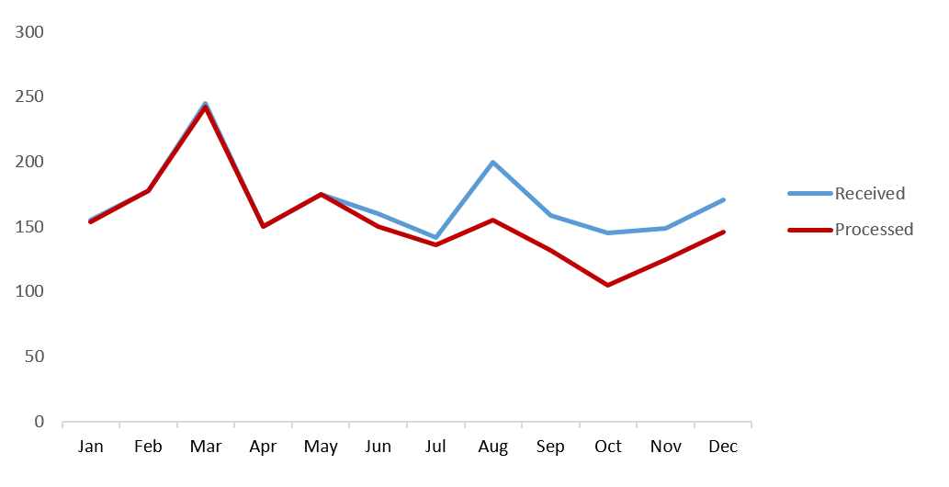

*Figure 4-8 Leverage Consistent Color in the Text Box Labels to Match Line Color*

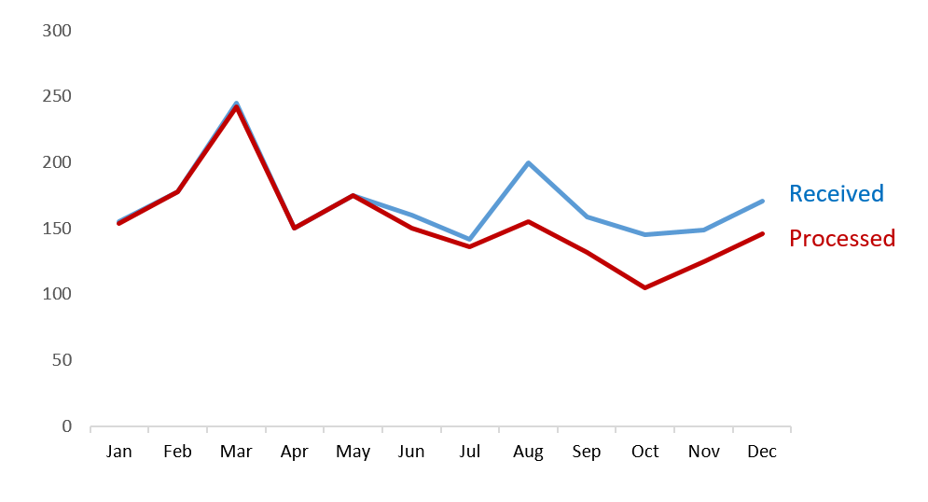

*Figure 4-9 Compare the Original Graph to The Simplified Graph*

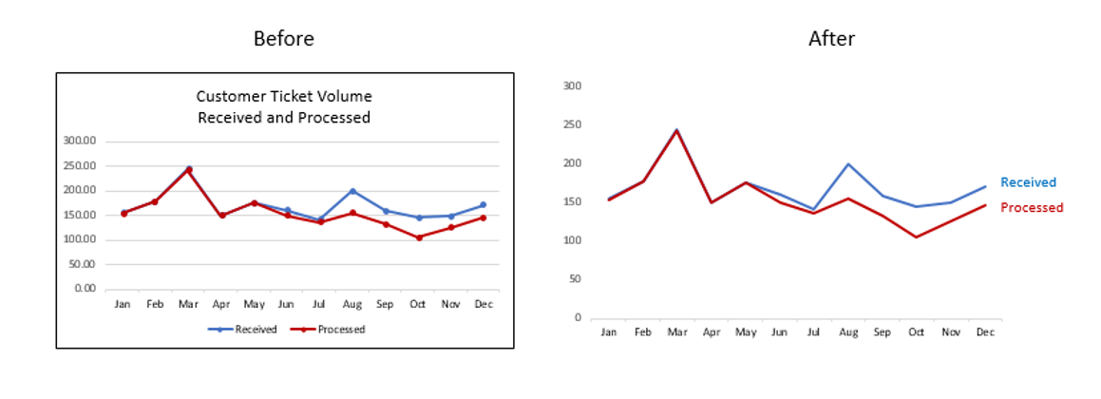

*Discrete and Continuous Data*

*This lecture will focus on two topics which are relevant to datasets, discrete data and continuous data. Having knowledge of these terms will make you much more prepared to handle a diverse set of business issues. Both of these terms are rooted in mathematics and explain whether data is represented by a distinct set of values(discrete) or*

*values which fall on a finite or infinite interval (continuous). Let’s take a look at a couple of examples of each.*

***Discrete Data***

*An easy way to think of discrete data is to interpret whether the data can be counted. For example, say that a husband and wife have four children together. The number of children can be counted. If you had a set of data representing different families and counted the number of children in each family, this would be a discrete data set. Same as if you were to count the number of vehicles driven by that family, or say the number of electronic devices owned by the family members.*

*Another way of looking at discrete data is to consider an elementary school. An elementary school has a particular structure in place. For example, usually it has one principal, one or more assistant principals, several teachers and many students. Each of these categories of the school structure can be counted, and is therefore unique and discrete. There is a specific count of teachers and students. Say there are 800 students in the school and 32 teachers. Students can also be discretely counted by the number of girls (448) and the number of boys (352) in the school.*

*Figure 4.2-1 Discrete Data Graph*

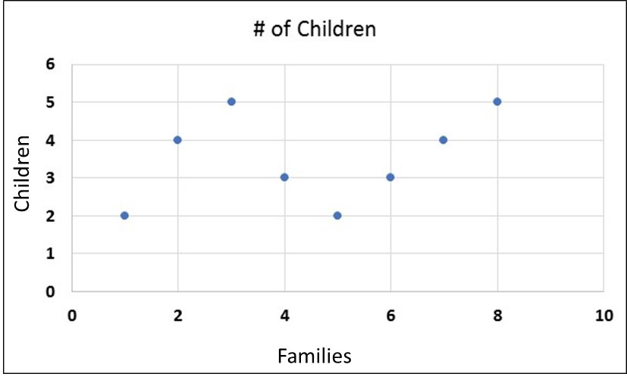

*Figure 4.2-2 Discrete Data Graph with Family Name*

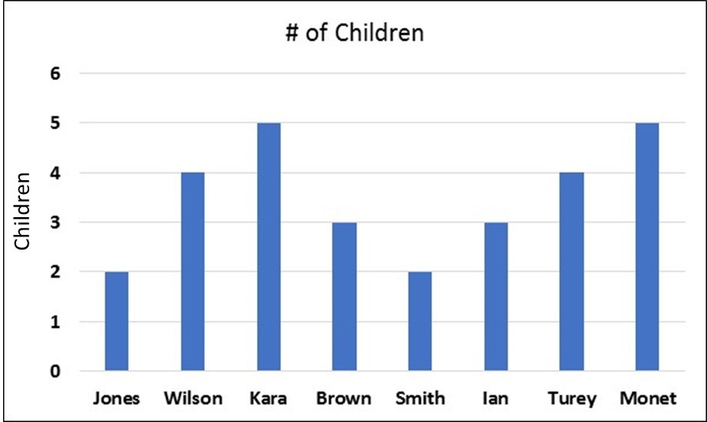

***Continuous Data***

*One way to understand what is meant by continuous data is to take a real life example and examine it. Take for instance time. If you were to graphs days, months, or years on a graph and trend into the future, how far would the graph go? Theoretically, the graph would “continue” forever, because time is never ending. Hence a calendar creates a continuous set of data. So a specific day can fall on any point along a time interval. Even though the day itself is unique, the interval of time is continuous. Therefore, the data set of calendar days would be considered as continuous data.*

*Even though continuous data can be found along an interval which stretches forever, such as time, continuous data can also fall along a finite interval. For example, if you wanted to measure the height of people in the world the data set containing each person’s height would be continuous. Height is something that you measure, and continuous data is measured data. The interval of various height would range from the shortest person to the tallest person. However, a person’s height can be measured at any value along the interval between the two, which is what makes the data in this example continuous.*

*Continuous data is also found in the category of weather. Consider the amount of rainfall as a metric. Even if you measure the amount of rainfall in a one year period, the interval of rainfall is continuous. It can range from 0 rainfall (which is not likely) and extend to the maximum amount of rain seen in a year. A specific measure of rainfall can occur at any point in between on this interval and is therefore considered to be continuous data.*

*Figure 4.2-3 Continuous Data Graph*

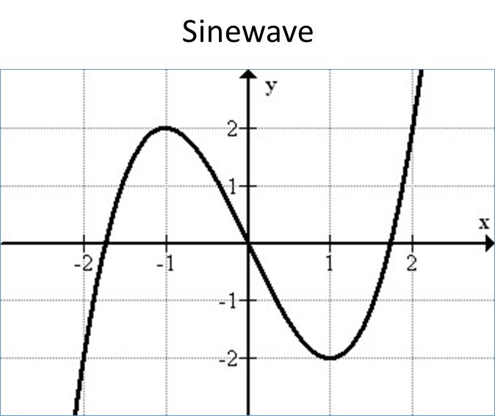

*Remember that continuous data is something you measure. Discrete data is something you count.*